**Zara Unboxed: Visualizing the Invisible Forces Behind Its Sales Growth**

A visual deep dive into the real drivers of Zara’s sales beyond discounts, placement, and seasonality. This case study uncovers how brand perception, pricing strategy, and a smart market positioning fuels consistent growth.

Abstract-: In the competitive fashion retail landscape, Zara demonstrates sustained sales growth. This case study investigates the underlying factors driving Zara’s sales growth using a **hypothesis-driven, visualization-centric methodology**. While numerical summaries provide insights, they act as **black boxes**, requiring technical interpretation. To bridge this gap, we use visualization that shifts balance from **cognition to perception,** taking advantage of our powerful eyes. We demonstrate how it uses **Gestalt principles** of perception to portray itself as a luxury fashion feel at an affordable price.

**Keywords**-: Zara, Sales Growth, Data Visualization, Hypothesis-Driven Analysis, Cognitive Load, Perception, Gestalt Principles

Introduction -: To formulate the hypothesis, we follow the CPQH format—**Context, Problem, Questions, Hypothesis** because it provides us a structured foundation, ensuring our hypotheses are grounded in facts, focused on real issues, and directed by investigative questions.

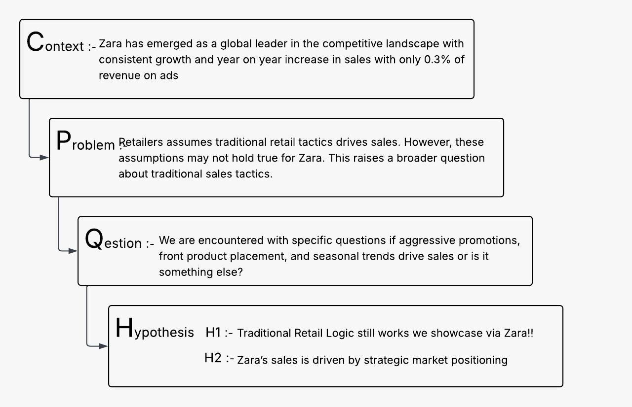

Zara, a flagship brand of the Inditex group, has emerged as one of the global leaders in the fashion landscape with over **2,200 stores across 96 countries**. Unlike traditional retailers that take **5–6 months** to roll out new styles, Zara’s supply chain delivers designs from runway to store in just **30 days**—a feat that allows it to stay ahead of fashion cycles and consumer expectations (Forbes, 2018). Zara spends **only 0.3% of revenue on ads**, vs ~4% by others. While traditional retail logic focusses on **promotions, pricing, product placement, and seasonality** as key drivers of sales, Zara’s sustained growth defy these all.

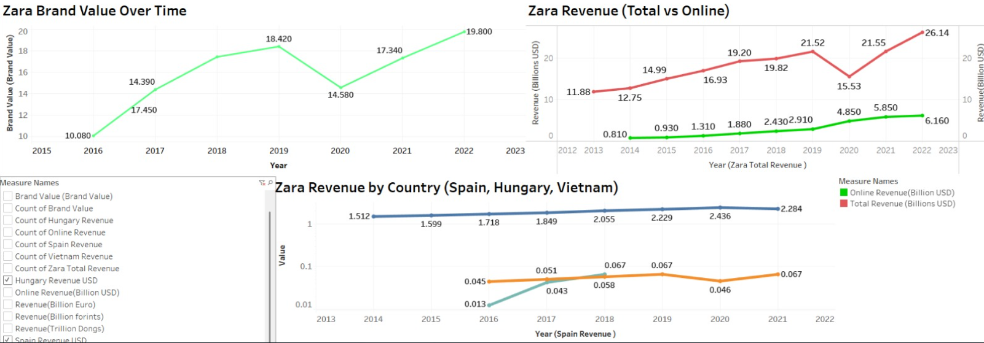

From the context we define problem -: Retailers often assume that aggressive promotions, front-of-store product placement, and seasonal trends are essential for driving sales. However, these assumptions may not hold true from the facts we see Zara defies them all and it is the perception that drive sales. This raises a broader question about effectiveness of traditional sales tactics.

We continue from here to go into the fine granularity drilling down certain specific questions

* Do promotional campaigns, physical placement of products significantly impact Zara’s sales volume, or is sales growth driven by other factors?
* Is Zara’s sales performance affected by seasonal variations across different product categories, or is the impact of seasonality minimal? How sensitive are Zara’s sales to price range sales figures?
* What role does consumer brand perception and Zara’s physical proximity to luxury brands play in enhancing its market position?

A Hypothesis is the tentative explanation that can be tested against data. Hence, we derive the following from the above which can be claimed.

Hypothesis 1: Traditional Retail Logic still works

Zara’s sales are influenced by traditional retail levers such as promotions, product positioning, or seasonality following conventional assumptions in the fashion retail industry.

Hypothesis 2: The Real Drivers Behind Zara’s Growth

Instead, Zara’s success is driven by a hybrid approach that blends fast fashion agility with luxury fashion release discipline positioning it uniquely between the two.

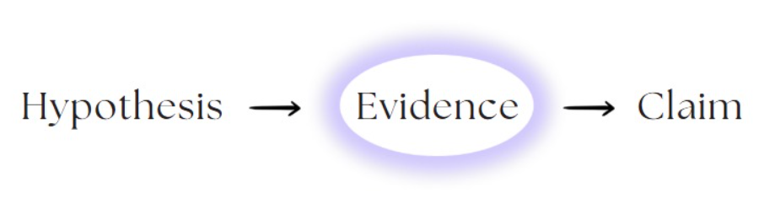

To gather evidence, we used the primary dataset given to us. Here is a brief description of it

Dataset-: This dataset, titled *"ZARA Sales"*, is available on Kaggle and was authored by Samuel Chinson (College Student) with the **motive** of research. It is based on primary data Zara Clothing, also available on Kaggle. It encompasses sales information from Zara. While the dataset provides insights, it is important to note that it is **not an official release by Zara.** Therefore, its reliability and accuracy cannot be verified.The dataset has **not undergone formal peer review**. However, it is accessible on Kaggle for public analysis and has been utilized in various exploratory data analysis projects.

linkto the dataset:- [https://www.kaggle.com/datasets/xontoloyo/data-penjualan-zara](https://www.kaggle.com/datasets/xontoloyo/data-penjualan-zar)

Data Abstraction-: Our dataset contains **10 categorical features** (e.g., *Product Category, Section, Brand, Product Position*) and **2 quantitative features** (*Price, Sales Volume*).

Methodology-: The greatest value of a picture is when it forces us to notice what we never expected to see." — John W. Tukey.

Suppose if we are given a task to assess whether promotional campaigns significantly impact Zara's sales volume. Using formulas like the *average* to compare sales during promotions vs. non-promotions acts like a black box, requiring prior understanding of calculations and offering little intuitive clarity. For many, especially non-technical stakeholders, this can be cognitively taxing.

**Why visualization helps:** A simple bar chart will immediately convey that sales volumes remain relatively flat regardless of promotion. It builds trust, invites exploration, and even a layman can grasp the insight without needing to interpret raw numbers.

This is what Edward Tufte meant when he said visuals “shift the balance from cognition to perception.” We're using our eyes, not memory or math to gain insights. **Hence, we use the method of visualization to bridge the gap between hypothesis and claims in our Zara case study.**

Timeline-: To ensure efficient execution of our project, we developed a detailed **Gantt chart timeline** covering the duration from **March 7 to April 7, 2025**. This timeline was structured across **four key weeks**, with tasks sequenced to maximize productivity and allow for overlap where feasible.

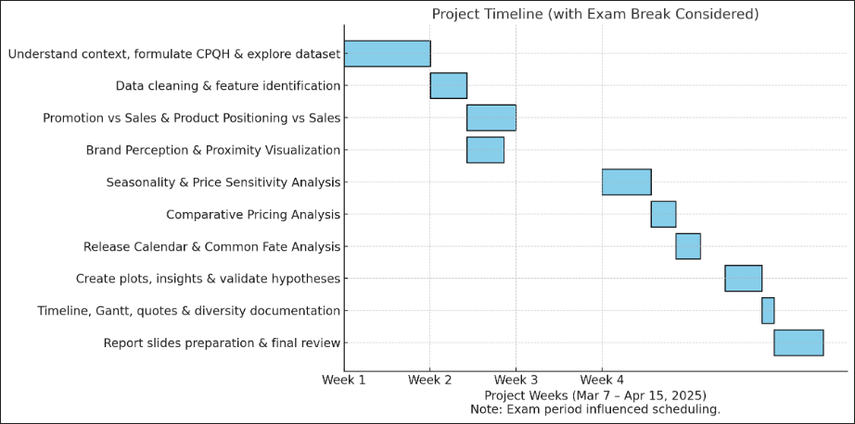

**Semantics:**

Fast fashion, Affordable luxury, Brand perception, Consumer behaviour, Fashion retail, Global apparel market, Brand positioning, Value-for-money, Competitive landscape, Trend analysis

We translate from domain domain-specific language to a more generic language through data abstraction

Visualizations

Hypothesis 1- Traditional Retail Logic is the key reason that drives Zara’s sales

Data abstraction

H1-: Promotion increases Zara’s Sales

Task abstraction

Task Objectives -: **Discover (Analyse) and Compare Distributions** between promotional and non-promotional sales periods.

Problem breakdown-: Analyse (Discover) -> Spread and Compare-> Distribution

Mapping with the relevant Visual Encoding Scheme (Idiom)-: Analyse Spread-> Box Plot

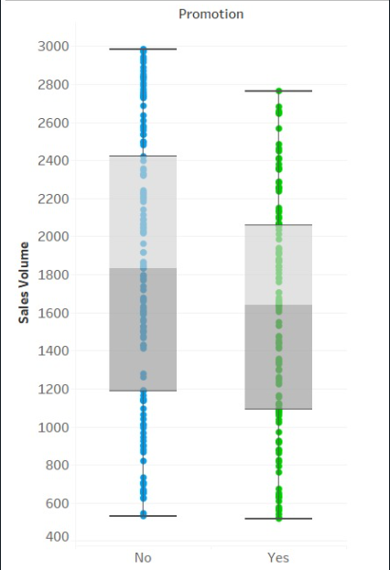

Analysis of Idiom-:

|  |  |
| --- | --- |
| Marks | 1D |
| Channel | Vertical Length  Colour (Hue)   * Ordered * Aligned * Separable |
| Action+ Target | Compare Distribution |
| Scalability | Can accommodate a dozen key but thousands of values for key |

Insights-: The box plot shows that **sales volume distributions are similar** whether a promotion is applied or not, with overlapping interquartile ranges. This suggests that **promotions do not significantly impact Zara’s sales volume**, indicating other factors may drive sales.

H2-: Product Position increases Zara’s sales

Task abstraction

Task Objectives -: Compare (Query) category with respect to sales and identify if there is any change.

Problem breakdown-: Compare-> Category

Mapping with the relevant Visual Encoding Scheme (Idiom)-: Compare category-> Bar Chart

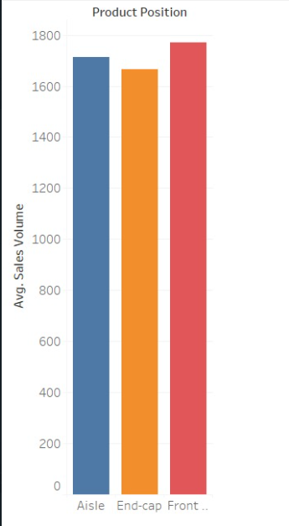

Analysis of Idiom-:

|  |  |
| --- | --- |
| Marks | 1D |
| Channel | Vertical Length  Colour (Hue)   * Ordered * Aligned * Separable |
| (Action + Target) | Compare Category |
| Scalability | Can accommodate dozens of keys and thousands of values for that key |

**Insights-:** Product position has minimal impact on sales volume, as all placements show similar average sales performance.

H3-: Seasonality affect Zara’s Sales-

Task abstraction

Task Objectives -: A **Z-score** (also called a **standard score**) tells you **how far a value is from the mean**, measured in units of standard deviation. The **Z-score** in our plot is important because it standardizes the data, making it easier to **compare seasonal vs. non-seasonal products**, even if their original scales were different.

Derived Data -: Z-score

Problem breakdown-: Analyse Distribution within categories

Mapping with the relevant Visual Encoding Scheme (Idiom)-:

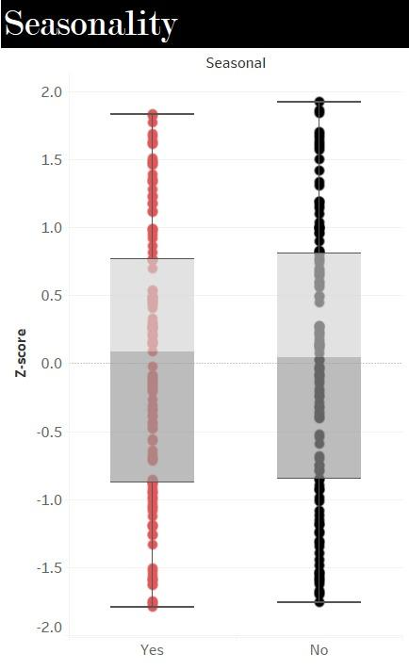

Analysis of Idiom-:

|  |  |
| --- | --- |
| Marks | 1D |
| Channel | Position  Vertical length   * Ordered * Aligned * Separable |
| Action+ Target | Compare Distribution |
| Scalability | Can accommodate dozens of Keys and thousands of values for them |

H4-: High priced products are sold more

Task abstraction

Task Objectives -: Find correlation if there is any between sale price and sales volume

Problem breakdown-: Find Correlation if any

Mapping with the relevant Visual Encoding Scheme (Idiom)-: Scatter Plot

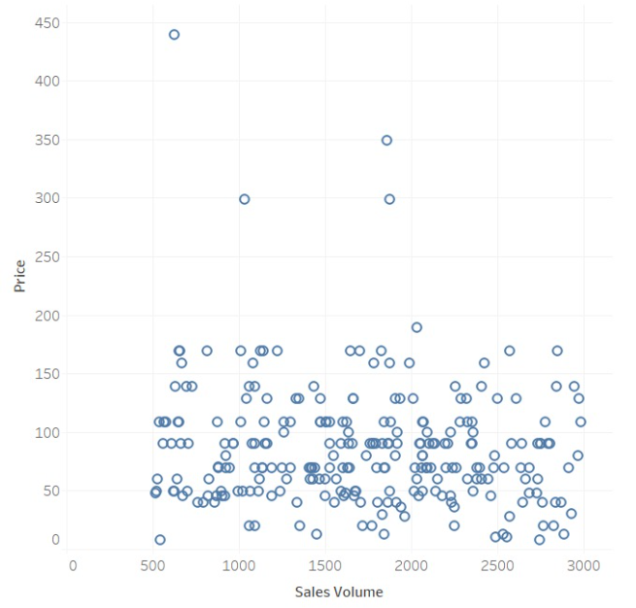

Analysis of Idiom-:

|  |  |
| --- | --- |
| Marks | 0D Point |
| Channel | Position   * Ordered * Aligned * Not separable |
| Action + target | Find correlation |
| Scalability | Can accommodate thousands of keys and thousands of values for keys |

Insights -: From the plot we see that low priced products are sold more can we imply it drives sales?

However, to confirm that our claim is reliable we did a **Diversity analysis of data** which measures how varied the values in each feature are, helping us to identify the richness and spread within the dataset. It is crucial to assess the **spread and representation** of categories, ensuring reliable and unbiased insights. **Shannon’s Entropy** is ideal for this, as it quantifies uncertainty and captures how evenly values are distributed within each categorical feature.



* A value near **0** means **low diversity** (e.g., one value dominates).
* A value near **1** (after normalization) means **high diversity** (many values equally likely).

**High entropy (or high diversity)** in a dataset is generally desirable, as it ensures broader representation across categories. This strengthens the validity and generalizability of insights or claims drawn from the data.

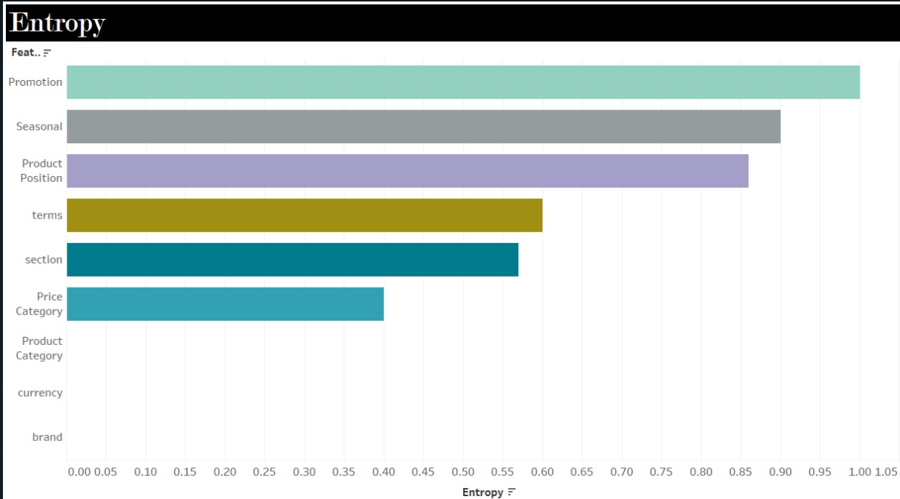

Insights-: For our data, we observe that the Price category has the least entropy, indicating the least diversity and class imbalance.

Hence, we cannot solely rely on this dataset for any claim, so we started a comparative study. We compared the prices across brands to see where Zara actually stands and what is the sales growth with respect to other brands to dig up the actual reason.

Pricing Strategy Comparison

Task abstraction

Task Objectives -: Analyse (**Discover) and compare** the pricing distribution across fashion brands and product categories.

Problem breakdown-: Compare → lookup values

Data Abstraction

Dataset Type-: Table

|  |  |  |
| --- | --- | --- |
| **Column** | **Type** | **Range/Cardinality** |
| Brand | Categorical | 10 |
| Product Category | Categorical | 6 |
| Adjusted Price | Quantitative | [10 – 10,000] (log scale) |
| Avg. Adjusted Price | Quantitative | [~50 – ~6,000] |

Mapping with the relevant Visual Encoding Scheme (Idiom)-: Compare value inter brands → Bar Chart

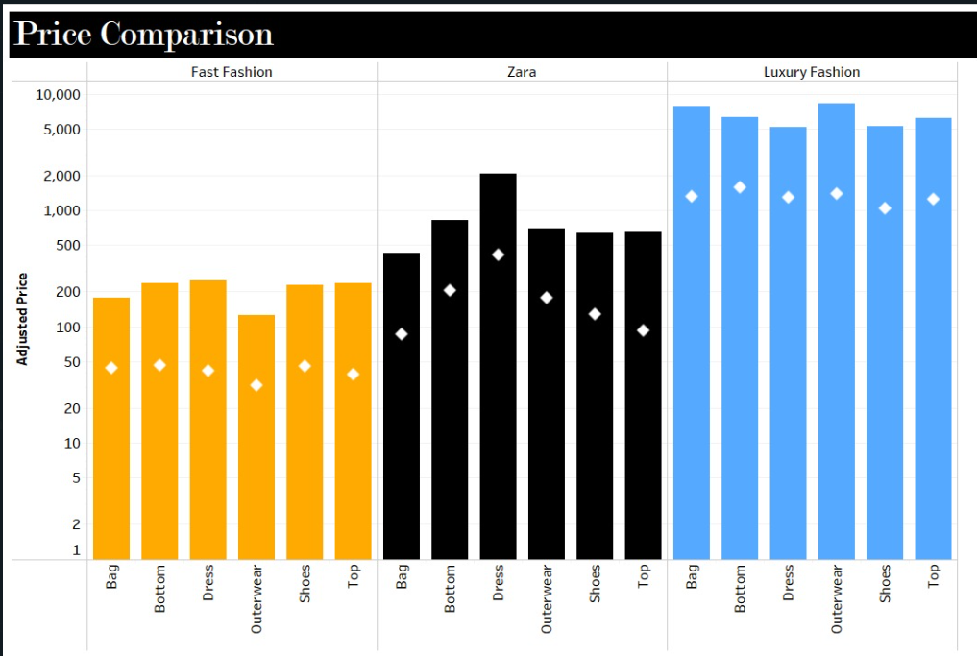

Analysis of Idiom-:

|  |  |
| --- | --- |
| Marks | 1D (line)  0D (point) median |
| Channel | Vertical Position  Colour Hue   * Separable * Ordered * Aligned |
| Action +Target | Compare Price |
| Scalability | Can accommodate dozens of keys and thousands of values for them, but juxtaposing them around different categories reduce scalability |

Insights-:

**Zara’s prices** are visually shown as **mid-tier**—noticeably higher than **H&M**, but significantly lower than **Prada** across all categories.

The **white dots** (average adjusted price) emphasize this tiering, showing **Zara positioned between** the two extremes.

The use of a **logarithmic y-axis** allows clear comparison despite the large price range.

2.) Market Position Understanding

Task abstraction

Task Objectives -: Analyse (Discover) Temporal change and Part to whole relation.

Problem breakdown-: Analyse-> trend and part to whole judgement

Data Abstraction

Dataset Type-: Table

|  |  |  |  |
| --- | --- | --- | --- |
| **Column** | **Type** | **Range/Cardinality** | **Description** |
| Year | Categorical / Temporal | 2013–2022 | Time period of analysis |
| Brand / Segment | Categorical | Multiple brands/categories | Individual layers in stream graph |
| Sales (Billion USD) | Quantitative | ~0–45 | Annual sales per brand/segment in USD |

Mapping with the relevant Visual Encoding Scheme (Idiom)-: Area Graph

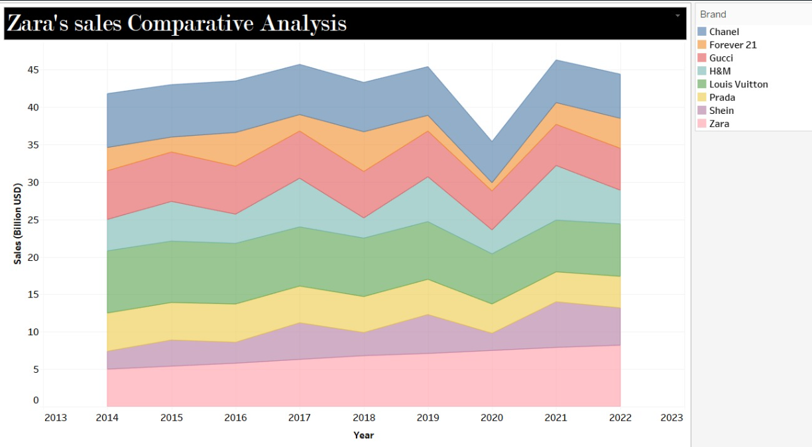

Analysis of Idiom-:

|  |  |
| --- | --- |
| Marks | 1 D (Line) |
| Channel | Colour (Hue)  Slope (Tilt)   * Separable * Aligned with respect to base colour * Ordered |
| (Action+ Target) | Part to Whole Relation.  Compare across categories. |
| Scalability | Can accommodate Dozens of Keys and thousands of values for each key |

Insights-:Zara in terms of price is very similar to fast fashion but shows a consistent growth like a Luxury brand, something different is doing!!

If the price was the actual reason that drive Zara’s sales, other fast fashion brands like HnM and Forever 21 would have demonstrated a very similar and steady growth like Zara. However, there is something more to it that is the key reason to drive its sales. Hence, we formulate the next hypothesis.

Hypothesis-: Zara’s Strategic market positioning as affordable, but luxury at same time drives Zara’s Sales.

The **Gestalt principles of perception** are a set of rules describing how humans naturally organize visual elements into groups or unified wholes when certain principles are applied. These principles were developed by German psychologists in the early 20th century to explain how we interpret complex scenes with many elements.

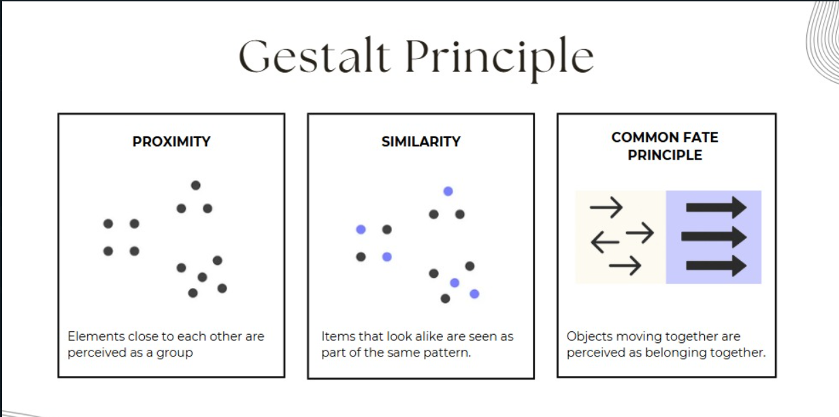

We hypothesize that Zara uses these principles to fit its brand perception into the cluster of Luxury brands.

Principle of Proximity-: Elements close together are perceived as a group.

Task abstraction

Task Objectives -: Study Zara’s Strategic Store Placement near to luxury brands rather than fast fashion brands.

Problem breakdown-: Study Proximity → Analyse data → Identify Pattern

Data Abstraction

Dataset Type-: Table

|  |  |  |
| --- | --- | --- |
| **Column** | **Type** | **Range/Cardinality** |
| City | Categorical | 10 |
| Country | Categorical | 10 |
| Brand Store Name | Categorical | 12 |
| Store Type (Luxury vs FF) | Categorical | 2 |
| Latitude, Longitude | Geographic coords | - |
| Average Selling Price | Quantitative | [$30-$3000] USD |
| Distance Metric from the nearest Zara Store  (Derived Data) | Quantitative | 0–x meters |

Mapping with the relevant Visual Encoding Scheme (Idiom)-:

Study Zara’s Strategic Store Placement near to luxury brands rather than fast fashion brands.

We wanted to study **the spatial closeness** between Zara and other stores. A scatter plot map is used to show store positions on a city map of various stores with coloured dots or symbols (LB vs FF), keeping the nearest Zara store as origin.

Analysis of Idiom-:

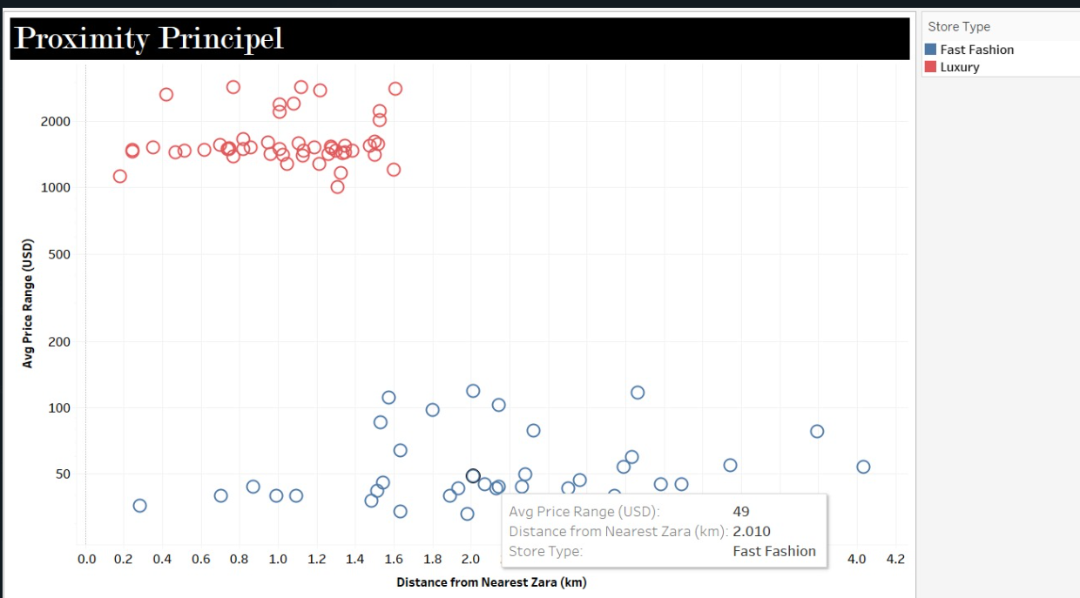

|  |  |
| --- | --- |
| Marks | 0D |
| Channel | Position and Colour (Hue)   1. Low Separability 2. Ordered 3. Unaligned |
| (Action Target) | 1. Analyse (Discover) Spatial data 2. Identify Pattern in All Data |
| Scalability | High (can accommodate 1000s of Keys and High range of Values for them |

**Insights-:**  Luxury Brands (that have a high selling price) are at a closer distance from Zara compared to fast fashion brands that are far apart

4.) Similarity-: Items that look alike are seen as part of the same group.

**Zara’s brand communication** (via words and themes) visually resembles luxury brands more than fast fashion competitors.

4i.) Via Words

Word Cloud

Task abstraction

Task Objectives -: Analysingand comparing frequently used words on Social Media handles and Campaigns

Problem breakdown-: Discover Word Usage → Compare Frequency

Data Abstraction

Dataset Type-: Table

|  |  |  |
| --- | --- | --- |
| **Column** | **Type** | **Range/Cardinality** |
| Brand | Categorical | Zara, Chanel, H&M, etc. |
| Word | Categorical | Varies |
| Frequency | Quantitative | 1 – 100 |
| Category | Categorical | Fast Fashion, Luxury, and Zara |

Mapping with the relevant Visual Encoding Scheme (Idiom)-:

Search Word Usage-: Word Cloud

Compare Frequency-: Table

Analysis of Idiom-:

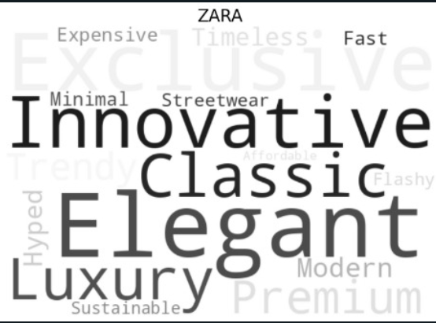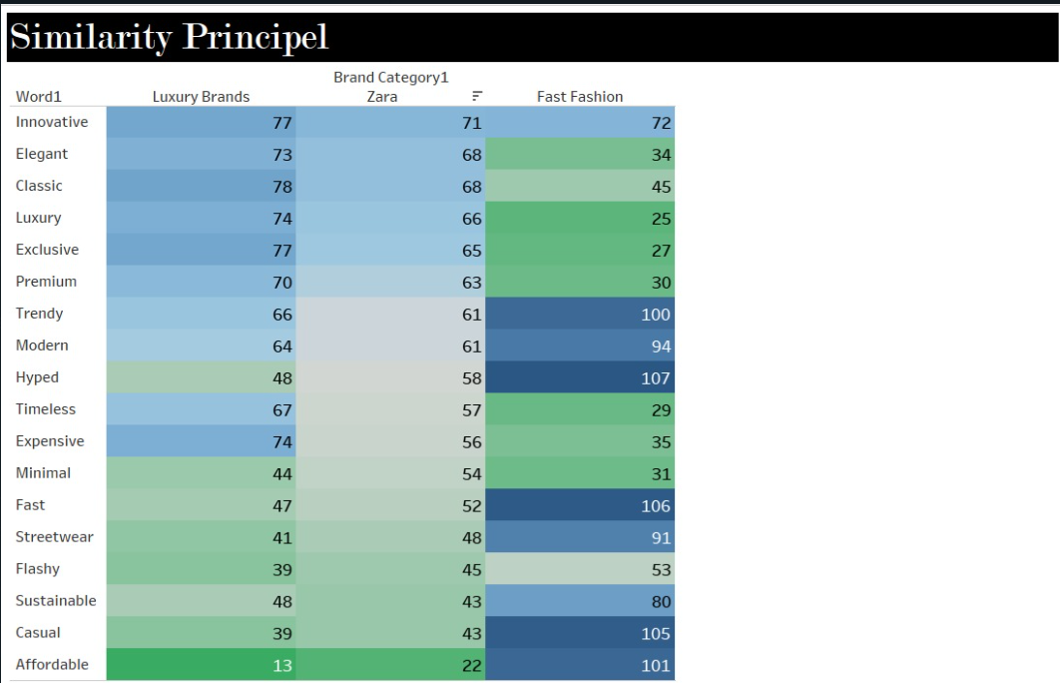

|  |  |
| --- | --- |
| Marks | Word Cloud (2D) |
| Channel | 1. Size 2. Colour Gradient in (Table) Saturation (Diverging)  * Separable * Unordered * Unaligned |
| (Action+ Target) | Search – Words  Compare-Frequency |
| Scalability | Low (Cannot accommodate not more than 20 keys and have high values) |

**Insights-:** We find that the word usage brand communication of Zara is very similar to that of Luxury brands compared to fast fashion brands

4ii) Via Themes

Task abstraction

Task Objectives -: Study Zara’s alignment with brands in terms of colour characteristics with other brands. **Discover** and **compare** Zara patterns with respect to various brands using colour features.

Problem breakdown-: Discover (Analyse) Colour Characteristics → Compare Pattern

Data Abstraction

Dataset Type-: Table

|  |  |  |  |
| --- | --- | --- | --- |
| **Column** | **Type** | **Range/Cardinality** | **Description** |
| Brand | Categorical | 25 unique values (brands) | Name of the fashion brand |
| Category | Categorical | {Zara, Luxury, Fast Fashion} | Branding type |
| Source | Categorical | {"Web", "Social Media"} | Where colour palette was derived from |
| Hue (°) | Quantitative | [0°, 360°] | Dominant colour hue |
| Saturation (%) | Quantitative | [0, 100] | Colour intensity |
| Brightness (%) | Quantitative | [0, 100] | Lightness level |
| Neutral Colour (%) | Quantitative | [0, 100] | Share of neutral tones like black, white |

Mapping with the relevant Visual Encoding Scheme (Idiom)-:

Analyse quantitative values → Scatter Plot

Identify Pattern → KDE Plot

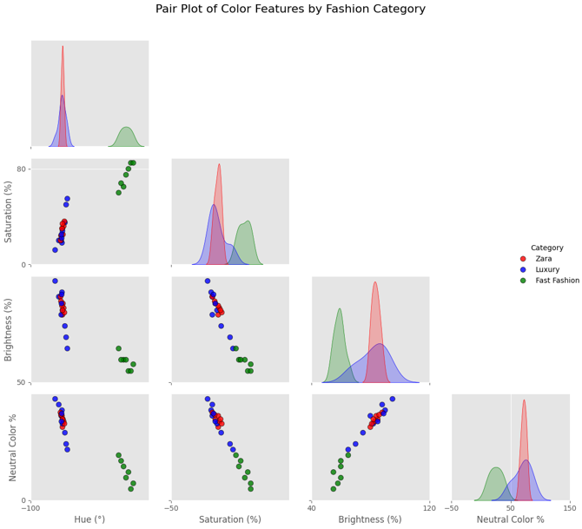

Analysis of Idiom-:

|  |  |
| --- | --- |
| Marks | OD |
| Channel | 1. Position 2. Colour Hue  * Not Separable * Ordered * Unaligned |
| (Action+ Target) | Analyse→ Features  Find → Pattern |
| Scalability | High (Can accommodate more than 20 keys and have high values for each of them) |

Insights-: Zara’s Brand communication via themes and colour palette is very similar to that of a luxury brand compared to fast fashion brand.

5.) Common Fate Principle-: Objects moving in the same direction are viewed as a unified group.

Task abstraction

Task Objectives -: Gestalt Principle of Common Fate to illustrate how Zara and luxury brands exhibit similar temporal dynamics in their release calendars, implying strategic alignment in pacing and rhythm of collection drops

Problem breakdown-: Compare Release-> Identify Pattern

Data Abstraction

Dataset Type-: Table

|  |  |  |  |
| --- | --- | --- | --- |
| **Column** | **Type** | **Range/Cardinality** | **Description** |
| Brand Category | Categorical | {Luxury, Zara, Fast Fashion} | Fashion brand group |
| Month | Ordinal | {Jan, Feb, ..., Dec} | Calendar month of release |
| Date | Quantitative | [1–31] | Day of the month |
| Number of Releases | Quantitative | [0–18] | Count of new releases on that day for the brand |

Mapping with the relevant Visual Encoding Scheme (Idiom)-:

Capture temporal Dynamics of 3 Different categories → Calendar Plot

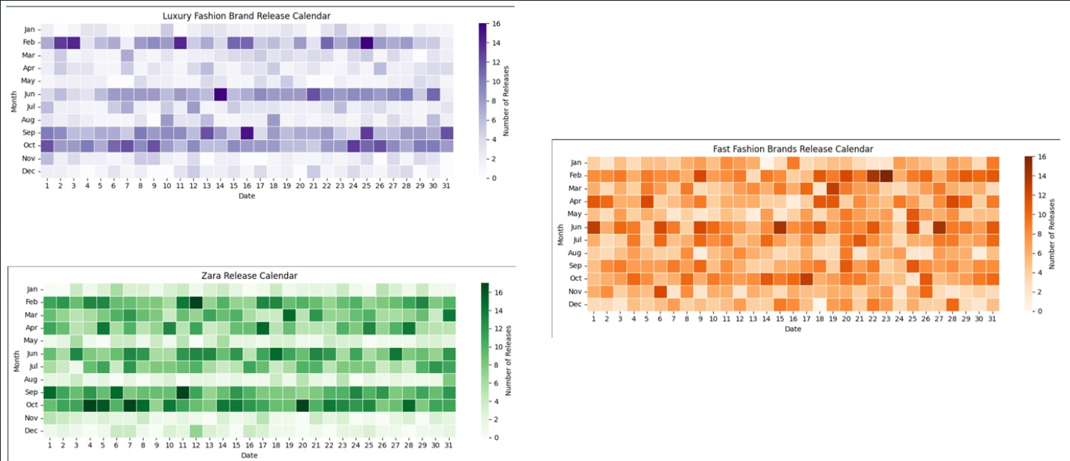

Analysis of Idiom-:

|  |  |
| --- | --- |
| Marks | 2D (Area) |
| Channel | Colour hue(inter-category)  Colour – Saturation (intra-category)  Ordered, Aligned |
| Action ↔Target | Compare Trends |
| Scalability | Can accommodate Less than dozens of Keys and Dozens of Values for that key |

Insights-: Zara’s fashion collection release pattern, as seen in the calendar plots, closely aligns with luxury brands in terms of seasonal timing such as spring/summer and fall/winter collections. This shows Zara’s strategy to project itself as luxury.

However, unlike traditional luxury brands that release only a few major collections per year, Zara releases new collections much more frequently. This mimics the fast fashion model, allowing Zara to respond quickly to changing trends and consumer demand, staying constantly updated on the shelves.

**Hence, we observe that Zara uses these principles to upscale its brand image, but how does it help Zara in driving its sale?**

6.) Sankey Diagram

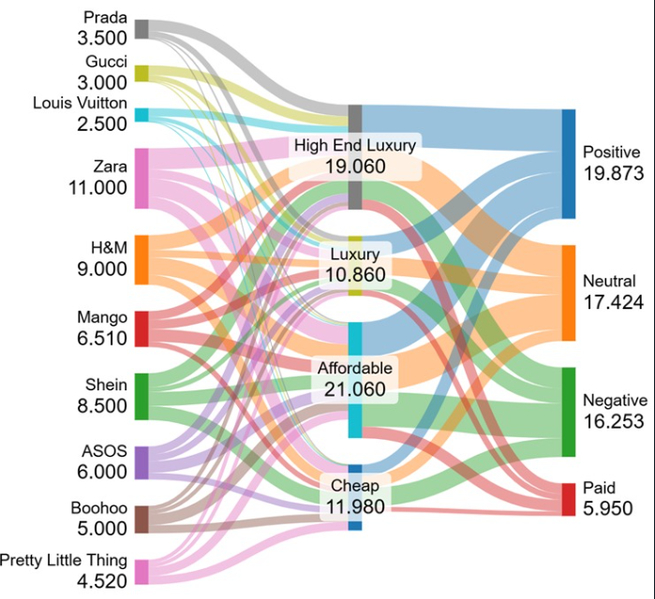

Task abstraction

Task Objectives -: To understand the flow of Perception about Zara around twitter and emphasize the fact that brand perception can be numeric, we demonstrated the flow diagram to understand the flow of perception and tried to quantify it for every year.

Problem breakdown-: Understand flow of perception

Data Abstraction

Dataset Type-: Table

**Dataset Type**: Table

|  |  |  |
| --- | --- | --- |
| **Column** | **Type** | **Range/Cardinality** |
| Brand Name | Categorical | ~10 |
| Market Segment | Categorical | 4 (High-end, Luxury, Affordable, Cheap) |
| Sentiment Category | Categorical | 4 (Positive, Neutral, Negative, Paid) |
| Volume/Weight | 10 Quantitative | Continuous (Percentage) |

Mapping with the relevant Visual Encoding Scheme (Idiom)-: Understand flow → Sankey Diagram

Analysis of Idiom-:

|  |  |
| --- | --- |
| Marks | 1D (Line) |
| Channel | Size  Width  Colour  Position   * Unordered * Aligned * Separable |
| Axis | Parallel |
| Action-Target | Analyse Flow |
| Scalability | Can accommodate dozens of keys and thousands of values for them. |

The Maths behind

The **Luxury Perception Score** reflects how strongly a brand is associated with luxury based on consumer perception. Instead of just counting mentions of “Luxury” and “High-end Luxury,” it also **penalizes** the brand for being seen as “Affordable” or “Cheap,” offering a more balanced view of its luxury image.

Affordable Luxury Index Formula Explanation

Objective

Our goal with this formula is to evaluate how well a brand strikes a balance between being perceived as luxurious and remaining price-accessible. We take into account both how consumers categorize the brand and the brand’s average selling price.

1. Weighted Luxury Perception Score

To calculate the luxury perception score, we use the following weighted formula:



Explanation:

– Each category of perception (e.g., High-end Luxury, Luxury, Affordable, Cheap) is given a weight based on how luxurious it is considered.

– The number of people in each category is multiplied by its respective weight.

– The sum is then divided by the total number of responses to get a normalized perception score.

Weights Used:

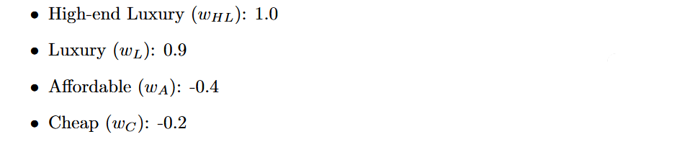

These weights reflect how each perception level contributes positively or negatively to the overall luxury score. The higher the weight, the more luxurious the brand is perceived to be.

2. Affordable Luxury Index (ALI)

Once we have the perception score, we compute the Affordable Luxury Index using the formula below:

ALI = 0.75 · Luxury Brand Perception Score − 0.25 · Average Selling Price

Rationale:

• We chose to give 75% weight to perception because brand image is a key factor in luxury branding.

• 25% of the formula accounts for price, as affordability plays a secondary—but still important—role.

• The negative sign on the price term indicates that a higher price reduces the affordability aspect.

**Note: This formula is part of our ongoing analysis project. Feedback and refinements are welcome as we test it against real-world brand data.**

7.) Conclusion-: Zara defies conventional retail logic. By analyzing sales data, correlating against promotion campaigns, and seasonality patterns, we proved in our analysis that traditional retail levers such as discounts and timing do not substantially impact Zara's performance.

Rather, our results indicate the strength of brand perception. By offering a luxury-like image—portrayed through minimum advertising, premium store layout, and timed drops—combined with the affordability and flexibility of fast fashion, Zara has established a distinctive position. This strategic brand positioning, more than traditional tactics, explains its success and dominance in the fast fashion market.

Task abstraction

Task Objectives -: Show Transition if sales increase with increase in ALI Score.

Problem breakdown-: Show correlation

Data Abstraction

Dataset Type-: Table

|  |  |  |  |
| --- | --- | --- | --- |
| **Column** | **Type** | **Range/Cardinality** | **Description** |
| Brand | Categorical | ~10 brands | Fashion brand names |
| Category | Categorical | 3 values | Luxury, Affordable Luxury, Fast Fashion |
| Annual Sales (USD B) | Quantitative | Continuous (0–30B) | Total annual sales in billions USD |
| ALI Score | Quantitative | 0–0.5 | Affordable Luxury Index (brand prestige vs. affordability) |
| Year | Ordinal | 2021 (filtered) | Time filter |

Mapping with the relevant Visual Encoding Scheme (Idiom)-: Find Correlation → Scatter Plot

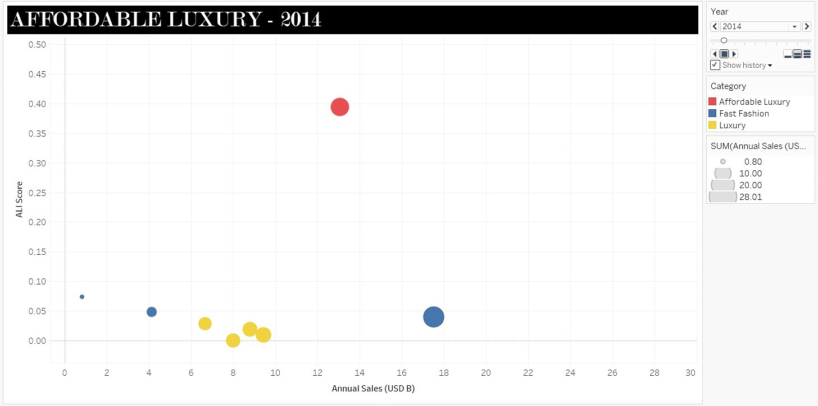

Analysis of Idiom-: As the ALI score increases for Zara its bubble size which has information about the sales encoded increases over time. Hence, we derive that Zara’s sales is driven by its positioning as Affordable Luxury.

|  |  |
| --- | --- |
| Marks | 2D – Bubble Size |
| Channel | Position  Color (Hue)  Size   * Ordered * Not Separable(Overlapping) * Aligned |
| Action-Target | Identify Correlation |
| Scalability | Can accommodate dozen of keys and thousands of values for that key. |

**References:**

**1.** [**Zara strategy**](https://martinroll.com/resources/articles/strategy/the-secret-of-zaras-success-a-culture-of-customer-co-creation/)

**2.** [**ZARA entry to Indian market**](https://www.mbaknol.com/management-case-studies/case-study-zaras-entry-into-indian-retail-fashion-market/)

**3.** [**ZARA using data analysis**](https://blog.fabrichq.ai/this-is-how-zara-leverages-analytics-to-dominate-fast-fashion-d8a4291214b3)

**4.** [**ZARA using data analytics (Harvard article)**](https://d3.harvard.edu/platform-digit/submission/zara-achieving-the-fast-in-fast-fashion-through-analytics/)

**5.** [**ZARA product positioning article**](https://radvilekisieliute1310689year2.wordpress.com/2015/12/28/zara-report/?utm_source=chatgpt.com)

**6.** [**Analysing the Strategic Impact of Zara’s Branding Strategies on Consumer Engagement and Market Position**](https://doi.org/10.1051/shsconf/202418503018)

**7.** [**Strategies versus Consumer Perception of Brand Zara-India**](https://www.researchgate.net/publication/335464169)